European Parliament workshop
Inequalities in access to cleft and craniofacial care
Brussels 27 February 2018

The European Cleft Organisation was delighted to be a key participant in a delegation to the European Parliament on 27 February 2018. The breakfast event, hosted by MEP Sean Kelly and attended by a diverse audience of other MEPs and policy makers, was an opportunity to get clefts and craniofacial anomalies on the Parliament’s agenda. The aim is to start pressing the European Commission for specific resources for cleft and craniofacial care in order to reduce the huge inequalities across Europe, enabling equal access to good quality lifelong cleft care. Speaking at the event, ECO Executive Director Gareth Davies, said ‘access to good cleft care is a basic human right and everyone born with a cleft and craniofacial anomaly should have the opportunity of realizing their full potential. There are a million people in Europe with clefts – equivalent to a city the size of Brussels. This is not a marginal concern and needs addressing urgently”
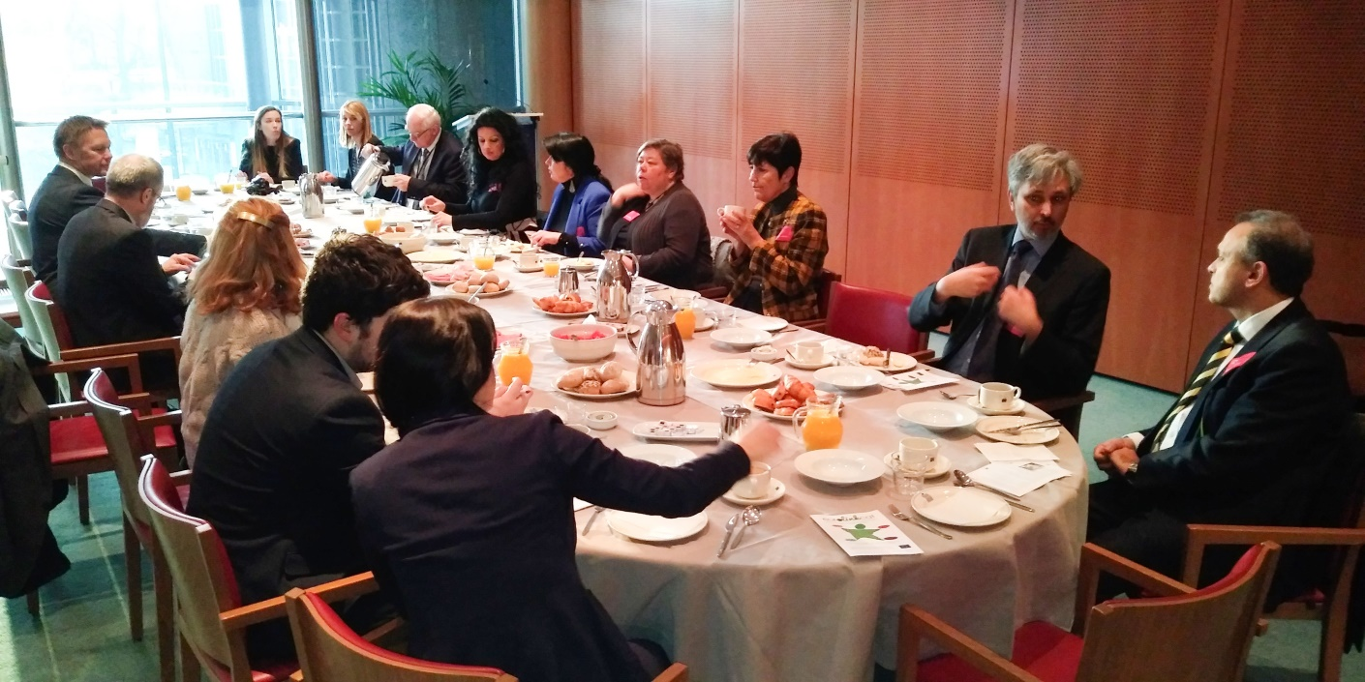
MEP Kelly, the Ireland South MEP and Leader of the Fine Gael delegation in the European Parliament hosted the gathering with fellow MEPs and experts in order to raise awareness of the issues and call for positive action to prevent inequality.“This is a forum to highlight inequality in access to care, and a compelling example of this is one relatively common birth defect, cleft lip and palate. The workshop will also be used as a forum to discuss and propose solutions in the context of research,” said Kelly.
In addition to ECO’s contribution and presentation, there were keynote addresses by Dr Martin Persson from Högskolan Kristianstad (University of Kristianstad) in Sweden and Prof Peter Mossey of the University of Dundee in Scotland. Dr Persson has worked extensively with the psychological and social determinants surrounding craniofacial anomalies and is currently the Chair of the COST Action 16234 - European Cleft and Craniofacial Initiative for Equality in Care. Prof Mossey is a Professor of Craniofacial Development and has a long track record of research on craniofacial anomalies in Europe, and also in the developing world, and as VP for the Global Oral Health Inequalities Research Network is well equipped to contribute to addressing the inequalities agenda in Europe.
The speakers explained how one in 700 births will have a cleft lip and/or palate, the most common birth defect affecting the head and face region. Estimates indicate there are over 900,000 individuals living with clefts in Europe, burdened by a complex treatment pathway from birth to adulthood, and affecting the patients and their families both physically and psychosocially throughout life.
The workshop outlined the medical, social and psychological problems of those born with facial clefts plus the inequalities in access to care depending on country of birth. Interventions and education that transforms lives for the benefit of the individuals, their families and society were also explored. MEPs present called on the European Commission to take action to effect change in this regard as did experts such as Amanda Neville from EUROCAT, Emma Southby from the European cleft Organisation and Ashraf Ayoub from the University of Glasgow. There was also input by Ashok Ganesh from CEN, the European Committee for Standardisation and Karina Marcus of COST – the Association for European Cooperation in Science and Technology. Significant European Parliament input came from MEPs Sean Kelly and Dr Miroslav Mikolášik, a medical doctor from Slovakia, as well as Anna Zapotocka-Zapalska on behalf of Polish MEP Mrs Julia Pitera.
It is imperative that a clear ‘wish list’ is put together which will be raised with the Commissioners by the MEP’s present at the meeting. There are clear arguments for including birth defects in the next EU funding calls (FP9) – the size of the problem (a million affected families in Europe); the ‘whole life’ aspect of being born with a congenital anomaly such as cleft lip and palate; the economic benefits of providing care that results in someone fully participating in, rather than becoming a burden to, society.
Anna Zapotocka-Zapalska let the group know that there was a variety of avenues to raise awareness of issues within the EU. She is currently working with the EU Petitions Committee on behalf of a doctor in Poland who had raised concerns about inequality of access to cleft care in her own country. See Annex. Everyone felt that this option should be explored and Anna offered to be the point of contact in this respect. More information about the Petitions process can be found here: https://petiport.secure.europarl.europa.eu/petitions/en/home
Professor Peter Mossey agreed to coordinate efforts towards developing an effective petition, signed by many stakeholders, most of which were represented at the workshop.

Annex

Petition No 0480/2016 by M.H.-D. (Polish) on standards and organisation of treatment of children with cleft lip and palate
Status: Available to supporters
Petition data
Summary title: Petition No 0480/2016 by M.H.-D. (Polish) on standards and organisation of treatment of children with cleft lip and palate
Petition number: 0480/2016
Topics: Health
Country: Poland
Petitioner data
Name: E. P.

Petition Summary
The petitioner, who is a health professional, asks the European Parliament and the European Commission to adopt common European standards for treatment of cleft lip and palate in children that will be applicable in Poland and the EU. She proposes adoption of the recommendations or programmes to achieve good and cohesive access to long-term treatment, based on generally applicable standards. She points out that in this respect Polish health legislation does not assure that “[E]veryone has the right to access preventive health care and the right to benefit from medical treatment, as provided by Art. 36 of the Charter of Fundamental Rights which is in turn based on Art. 138 paragraph 1 of the TFEU stating that “[A] high level of human health protection shall be ensured in the definition and implementation of all Union policies and activities. Union action, which shall complement national policies, [.]” She is of the opinion that treatment of cleft lip and palate in children in Poland is not correct and not in line with standards that are currently applied in health systems in the EU.

