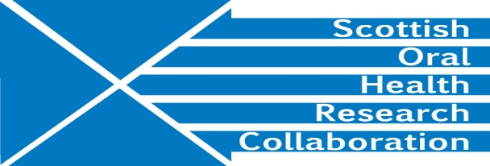

Minutes of the SOHRC Dental Education Research Group Meeting at the University of Edinburgh Dental Institute, room 7009 on Monday 22nd January 2.00-4.00pm
Present: Prof Angus Walls (Chair), Prof Jeremy Bagg, Dr Ann Shearer, Dr George Cherukara, Dr Vivian Binnie, Deirdre Kelliher
Apologies: Kevin Davey, Nicola Innes, Linda Gunn, David Felix, Jennie Foley
- Minutes of previous meeting
A number of corrections were requested – Action DK
It was noted that Aileen Bell is now the contact for Lift up in Glasgow.
- Discussion of Conference Workshops Summary
The meeting expressed thanks to Kevin Davey for providing a very useful summary of the SOHRC conference workshops which picked up on the main themes of the day. The SOHRC Education group should aim to engender collaborative work among schools in the future.
There is scope for a future collaborative research project on MMIs and how they operate in the different institutions. The Board for Academic Dentistry is interested in the possibility of standardising MMIs.
There are certain anxieties about selection process and whether MMIs are a reasonable tool. A high quality, long-term research study is needed. To take this forward AW will contact the Heads of Institutes/Schools to establish whether they wish to be part of a study . Action AW
The next stage will involve getting the |MMI leads from the different institutions together for an initial meeting. Action DK
Jamie Dickie’s research LIFTUP is of interest to the Education Group and he should be invited to present at a future meeting. It was also felt that it would be useful to invite all the NES lecturers to present at future meetings. AS will provide DK with a list of names. Action AS
- Existing research
Glasgow: VB mentioned work on the Importance of scholarship and learning technology at Glasgow. She is also looking at digital resources.
Aberdeen also has a scholarship project. They have been looking at the impact of stress on students and comparing new methods of teaching with traditional teaching. GC also mentioned work on clinical skills and scanning techniques. It might be useful to produce a newsletter informing all the Schools about current education research. This could be posted on the SOHRC website. VB and GC will send DK some further information. Action VB and GC
- Future direction
Covered above.
- Funding opportunities
DK provided information on possible funding opportunities:
The links to the schemes mentioned at the meeting are:
ESRC
http://www.esrc.ac.uk/funding/funding-opportunities/research-grants/
http://www.esrc.ac.uk/funding/guidance-for-applicants/is-my-research-suitable-for-esrc-funding/remit-query-form/
Association of Medical Education
https://www.asme.org.uk/awards
Society for Research Into Higher Education
https://www.asme.org.uk/awards
VB mentioned the Learning and teaching development fund at Glasgow. Other Universities may have something similar.
- AOCB
JB reported on papers accepted for publication. He will provide references to include in the Group newsletter. Action JB
AW will forward details of the Day of Dental Simulators. Action AW

- Date of next meeting
After the meeting of MMI leads. Action DK

