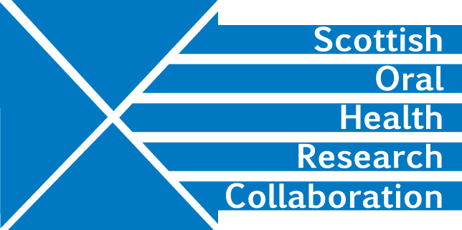

Minutes of the SOHRC Craniofacial Research Group meeting held on Wednesday 28th November 2018, 3.30-5.30pm at Dundee Dental School, in the Campbell Room

Apologies: Mairead Bermingham, Angus Walls, Grant McIntyre, Kurt Naudi, Aileen Bell
Present: Peter Mossey, Felicity Mehendale, Ashraf Ayoub, Xiangyang Ju, Bodore Albaker, Gawri Reesu (Vijay)

- Minutes of last meeting
The minutes of the last meeting were found to be correct

- Update on NIH application and future plans
The NIH application submitted in conjunction with the University of Maryland has been rejected. Seth Weinberg has not yet received feedback but will pass this on in due course.

The group decided to repackage the application and submit to a UK or EU funder, possibly one with an interest in facial reconstruction. The application is already scientifically robust but demonstrating the advantages of the research to the health of the UK population is important to funders.

PM will contact Caroline Wilkinson, professor in forensic science at Liverpool John Moores University with regard to possible collaboration and advice Action PM

- Update on Bodore Albaker Craniofacial project
PM provided the group with the project information presented to the Qatar government funding agency. BA and PM have worked on the protocol and BA will send AA a one page summary and request feedback. Action BA and AA

DK will investigate with Debra Stuart, University of Glasgow Governance Officer how BA can gain a Research Passport which will give her access to Glasgow patients. Action DK

Trish Burns may be able to help BA with IRAS registration.

- Update on Zika virus project
AA has invited the paediatrician, Dr Adriana and Leonardo Freitas to come to Glasgow. AA estimates the cost of their travel to be £3-4K. It might be worth looking at Royal Society funding to see if their costs could be covered

- SOHRC spring event - student thesis 3 minute presentations
Students from both Glasgow and Dundee should present. The group should meet again in January to discuss which students to include.

- AOCB

- Date and Venue for next meeting

8th January, University of Glasgow. DK will book a room and confirm arrangements to the Group. Action DK

