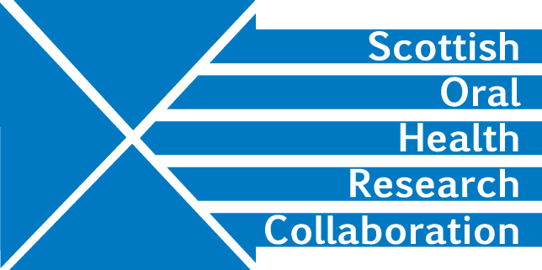

Minutes of the Dental Education Research Group Meeting of MMI Leads, University of Edinburgh Dental Institute, Thursday 27th September from 10.30-12.30, James Main Meeting room

Present: Malcolm Stewart, Linda Gunn, Amber Brown, Viv Binnie, Liz Conner, Fiona Stewart, Deirdre Kelliher

1. Welcome and Apologies
MS welcome the Group to the meeting. Apologies were received from Christine Goodall.

2. Minutes from Last meeting and matters arising
No amendments were requested.

Action point 4: VB agreed to follow up with CG with regard to data protection issues. She will also discuss the matter with Andrea Sherriff at the University of Glasgow. All members of the group felt that they could not move forward with a collaborative project until procedures for sharing data were clear. Action VB

Action point 5: MS has set up a Dropbox for sharing files and some papers have been inserted but it was noted that Liz Conner is unable to access this. MS will investigate the problem. Action MS

3. MMI- How do we create new stations/ questions?
The group explored the pros and cons of a national approach to MMIs and whether it would be possible to conduct MMIs for all Schools in the one place on the same day. There was an awareness that all schools are competing for the same students. The number of students recruited to Dental Therapy courses is low in comparison to the number recruited for Dentistry. LG has arranged a meeting with the other Dental Therapy Schools to discuss the matter.

Dates for MMIs in individual institutions are generally set one year in advance. The Group agreed to share dates in the future to reduce the amount of travelling for candidates and avoid clashes. Action All

For 2019 the dates are as follows:
Highlands and Islands – Jan
Dundee – Feb
Edinburgh – March
Glasgow – Feb
Aberdeen – Dec
Glasgow Caledonian – possibly March

How often do we review our stations?
Highlands and Islands (5 stations) sets an action plan and timetable for reviewing and adjusting the process. This begins in the summer when they review feedback from students and staff obtained through an online survey. In October they work through the stations with relevant staff members and then finalise these ready for MMIs to begin in January.

Dundee (10 stations) tries to introduce some new questions each year. Staff feedback forms are completed and reviewed after the annual MMIs have taken place.

Edinburgh (5 stations) introduced MMIs in 2014. They recognise the need to review stations and LC is working on this.

Glasgow (7 stations) holds a workshop each year to looks at its stations and questions. It takes feedback from students into account. There are some new questions each year.

Aberdeen (9 stations) varies questions and changes scenarios each year.

What qualities are we looking for?
Should there be a Scottish map of attributes required for Dental professionals? Glasgow has produced a working document. VB will investigate whether this can be shared with the Group. Action VB

Manual dexterity is assessed in both Aberdeen and Edinburgh but this may be a skill which can be learned.

How do we write questions to assess these?
Each School sets its own themes. Could these be shared to help other Schools in the task?
Highlands and Island focusses on Healthcare and Societal issues, Communication, Ethical issues and IT skills.

Both Glasgow and Dundee have engaged psychologists to assist in the process. Institutions should consider whether their templates could be shared. Action All

4. Research into MMIs Scotland
What research is each school doing/ has done in the past?
Some research has been carried on an institutional level but lack of clarity relating to data sharing and prevented collaborative research.
Edinburgh has a post grad student looking at MMIs but the student does not want to share her work before publication. LC will let the Group know when this paper is available and put it into the Dropbox. Action LC

What would do we want to measure?
Performance as undergraduate
Performance in practice
Professionalism

What research question(s) should we be asking on the way forward?
Are MMIs beneficial? Are they better than traditional interviews and are they fairer for candidates? Research suggests that they are more effective for selecting medical students.

Can professionalism in practice be linked to behaviour during the course?

Why do students drop out?

Can we identify which dental therapy candidates join a course with the intention of moving on to a dentistry course?

Research needs be collaborative to have sufficient data to answer these questions The starting point is a literature review to establish what research is being/has been carried out. At that point a research project can be designed but data sharing issues must be clearly understood before any collaborative research can begin.

- AOCB
DK mentioned the SOHRC 2019 conference plan to include a student 3 minute theses competition under the 3 SOHRC themes and asked how many dental education research students would present. There is one from Glasgow. LC will check to see if there are any students from Edinburgh and will let DK know. Action LC

- Close and date of next meeting
The first week of January or mid-February are possibilities. DK will get dates from MS and set up a Doodle poll. Action DK

