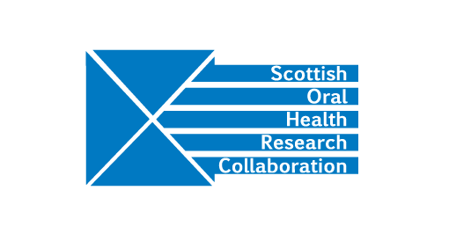
SOHRC Education Research Group: Meeting of MMI Leads, Wednesday 2nd May, 10.30-12.30, Dental Directorate Meeting Room (DDMR), 4th Floor Lauriston Building, Edinburgh Dental Institute
Present: Angus Walls, Jeremy Bagg, Malcolm Stewart, Christine Goodall, Fiona Stewart, Liz Conner, Linda Gunn, Amber Brown
Apologies: Angela Pilley
Minutes
- Welcome and apologies
AW welcomed the group to the meeting.

- Introduction
AW explained that the work of the SOHRC Education research group began with the commissioning of the Delphi exercise. The 2017 conference discussion groups and the further Education research group meeting in January identified a possible future research project on MMIs and their effectiveness in terms of student performance and future clinical outcome.

- MMIs – current practice
Aberdeen has 9 stations to assess Knowledge, Experience, Communication/Empathy, Comprehension, Manual dexterity. 87 students are interviewed over 3-4 days.

Glasgow has 7 stations and uses actors. It publishes information about MMI contents and practice on its website. 200 students are interviewed over a weekend.
Edinburgh has 5 stations (8 minutes for each) looking at leadership and management, communication, manual dexterity, professionalism/ethics and an interview station (this station covers career aspirations/knowledge/experience).
Staff and students are involved in role-play exercises. 60 students are interviewed over two days.

Dundee has 10 stations (7 minutes for each) looking at Communications, moral judgement, role-play, team working. 250 students are interviewed over 8 days.

Highland and Islands looks at communication, empathy, societal issues, team working, and uses role-play involving both staff and current students. Candidates are given the questions in advance. 70-80 students are interviewed.

- Questions for consideration by this group:
How often do different institutions review MMI questions?
Would it be advantageous to establish a common bank of MMI questions?
Are different institutions looking for different qualities?
Is it possible to share institutional frameworks and good practice?
Do admissions procedures bring in successful students who become successful clinicians?
Did students who performed well at MMI stations also perform well with course work?
Would a common baseline allow the group to look at Scotland-wide outcomes?

Each University has gathered a lot of data from MMIs but there may be data protection issues and Caldicot guardian approval may be required. JB and CG will investigate further and report back to the group. Action JB and CG

- Moving forward
MS will be the group lead and FS will assist. MS will set up a Dropbox for the sharing of ideas. Action MS

Edinburgh will host the meetings. DK will liaise with Jackie McGurk at the Edinburgh Dental Institute. Action DK

- Date of next meeting
The next meeting will be in September/October. DK will contact MS for dates and then set up a doodle poll for the group. Action DK

