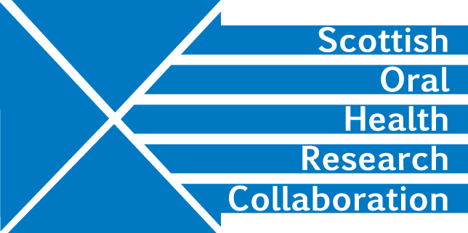

Minutes of Dental Education Research Group Meeting of MMI Leads, University of Edinburgh Dental Institute, Thursday 21st March 2.00-4.00pm
Present: Malcolm Stewart, Linda Gunn, Liz Connor, Amber Brown, Deirdre Kelliher

- Apologies were received from Fiona Stewart, Christine Goodall, Viv Binnie
Given that there were no representatives from Glasgow or Dundee Dental Schools, the group agreed to concentrate the discussion on the Dental Therapy Schools.

- Minutes of last meeting
No amendments required.

- Matters arising
MS had discussed data protection issues with Viv Binnie as agreed see item 4 below.

LC can now access Dropbox.

- Information sharing/Information Governance
Information about processes and operations in individual institutions can be shared but student data must be anonymous and ethical approval must be gained before any research begins.

- Research – what to do now?
Possible research themes include:
Selection – identifying when/why students choose Dentistry as a backup for Medicine or Dental Therapy as a backup for Dentistry.

Retention – how robust are MMIs? What are students’ expectations? Are their pre-course perceptions important? Is experience of value and does this have to be dental experience?

What are the attributes for success? How are they assessed? Could the development of more appropriate stations with better trained assessors improve selection processes? It may be useful to engage with Psychology departments.
What do students do when they complete their course? This may be a difficult area to follow up due to sparsity of information, lack of opportunities for Dental therapists.

MS will contact Viv Binnie to seek her advice on formulating a suitable research question Action MS

- Our processes -scope for sharing of information to improve the Scottish admissions process
Interviews and MMIs
Institutions have similar but individual processes operating with a combination of MMIs and applicant interviews. They are often interviewing the same students and so there may be considerable duplication of effort. Could the Schools agree to a system of central MMIs with applicant interviews in individual institutions? LC would like to see institutions coordinating dates of interviews.

Schools weight stations according to their own system. Edinburgh, for example, allocates a lower weighting to skills which can be learned. 40% is given to the applicant interview. The Group should consider whether stations are fit for purpose.

Selection
Schools have again similar but individual processes. Most involve the Admissions department as well staff from the Dental /Dental therapy Schools.
How successful are selection processes? Have dropout rates declined since the introduction of MMIs?

Group members should give consideration to these areas and add information to the Group Drop box before the next meeting. Action all

LC will invite her PhD student to present at the next meeting. Action LC

- Dental Education Conference
It was decided that the Group was not ready to produce a poster for this year’s Dental Education conference.

- AOCB
The Group should consider holding a skype meeting in between face to face meetings. MS will check progress with the group in 2-3 months and arrange a skype meeting if this would be helpful. Action MS

- Date of next meeting – Sept/Oct. Dk will seek dates from MS and set up a Doodle poll. Action DK

