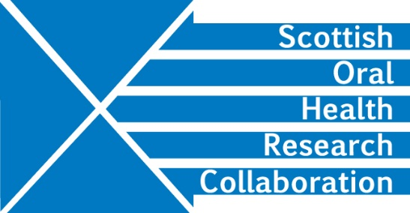
SOHRC Education Research Group: MMI subgroup (Dental Schools only)
Brainstorming session, Wednesday 27th November 2-4.00pm, Glasgow NES Dental Education Centre.
Present: Malcolm Stewart, Fiona Stewart, Viv Binnie, Christine Goodall, Deirdre Kelliher
Meeting notes
The group met to discuss possible research questions in relation to the admissions process in Dental Schools with the aim of formulating a preferred single question to allow the group to move forward with a research project.
Existing research
The Group noted Claudia Cunningham’s literature review on Admissions in Europe which demonstrated a lack in research in Dental Education.
Claudia Cunningham and Jamie Dickie are both active in education research and presented at the SOHRC October conference.
Data, GDPR, Ethics
Each University gathers a lot of data – MMIS, Entry data, Liftup, Exam results, OSCEs, ISCEs (Aberdeen only)
However, sharing of data among Universities may be restricted by GDPR.
How does each University obtain consent from its students to use this data?
Dundee, Aberdeen and Glasgow all have consent forms but there may be a need to examine these carefully to establish what permissions are given when these are signed and whether this is clear to admissions candidates. MS will circulate a copy of the Aberdeen consent form to group members. Other Group members may want to do the same. Action MS/All
Can UKAS data be used without obtaining further consent? What about anonymised data? The group thought that there could be problems with data linkage and that it would be necessary to go through GDPR processes at each institution.
It was noted that George Cherukara is currently setting up a SOHRC GDPR group to try and iron out issues.
Ethics: the group would have to obtain ethical approval from each institution involved before any research project could commence
MMIs measure desired attributes.
Themes are currently similar in different Universities but the stations used at MMI interviews are different. Some Universities involve students in the MMI process, some use University and NHS staff. Are some attributes more important than others e.g. diligence or professionalism, preparation for practice?
The basic question for research is whether students who perform well at MMI interviews also perform well in their studies and in their later career.
The Group could look at a few subsets.
Possible Subsets:
Widening participation in areas of deprivation.
Overseas students
Students selected at Results time
Young people who are looked after and accommodated (Care)
Refugees/asylum seekers.
Students with learning disability – dyslexia, Asperger’s syndrome
Estranged students
Independent schools v state schools.
The research question
The group decided that the project should be limited to performance in Dental Schools and the question would be:
Are MMIs predictive of good outcomes in Dental Schools in Scotland?
Project requirements:
Define outcomes
Discussion with Claudia Cunningham and Jamie Dickie
Involve admissions officers, CIDERS group
One-year Student/RA to look at data, ethics etc.
Project plan
Stage one: Look at individual Schools
Stage two: Link School studies
Next steps
VB will invite Jamie Dickie to speak to the Group (Feb/March). Action VB
VB and CG will send the group relevant papers. Action VB/CG
Each group member should look at the subject areas covered by their Institution’s MMIs and the associated attributes to ascertain common themes at the next meeting. Action All
Next meeting End of March – DK will seek dates from MS. Action DK

