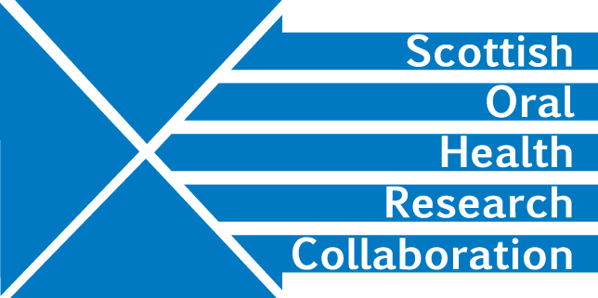

Minutes of the SOHRC: Craniofacial Research Group: Research leads Zoom meeting, 10.00-12.00pm, Tuesday 30th June
Present: Peter Mossey, Ashraf Ayoub, Felicity Mehendale, Xiangyang Ju, Deirdre Kelliher
- Smile Train update and future possibilities
The Smile Train is a major player in the cleft and palate field and is now developing research interests. PM and FM sit on its Medical Advisory Board and are assisting with the formulation of the charity’s future research strategy. It owns the Smile Train Express Database on cleft. FM has written a paper (currently confidential) on how the data might be used to best advantage. FM will send a copy of her paper to YJ.
Action FM
FM ‘s paper comprises a proposal and a number of work packages. Funding is needed for each of the packages. Work package one aims to prepare the database for use and so a potential funder would need to be interested in capacity building. The Group agreed to focus on this package and members will investigate CSO opportunities. Action All

XJ suggested that the Group should hold discussions with Stuart Parks, Head of Clinical Engineering for NHS GGC and invite him to join an advisory group. Involvement of the NHS would strengthen a research proposal and would be viewed favourably by research funders. FM will discuss with her research group
Action FM
- SPARKS funding opportunity (collaboration)
AA has produced a draft proposal that could be submitted to the current Rare Disease call from SPARKs. PM will check that cleft is considered by SPARKS to be a rare disease.
Action PM

AA requested feedback on the draft proposal particularly on methodology, impact and innovation. The deadline is 19th August.
Action All

A discussion ensued on whether a collaborative 4 Centre application to include Temple St in Dublin would be advantageous though it was decided that forming a consortium in time for the SPARK’s deadline would be difficult. FM will contact Nick Whyte to see if he is interested in collaborating in the future.
Action FM

- PhD project _ Bodore
The pandemic has affected recent progress though up till that point preparatory work was going well.

- AOCB / Date of next meeting
3rd week in July. DK will arrange a further Zoom meeting.
Action DK

